**PRACTICAL – 10**

**Aim: Program to pass two list of integers in a function that will create third list that will contain all odd numbers of both given list on its left side and all the even numbers both given list on its right side.**

Code:

Output:

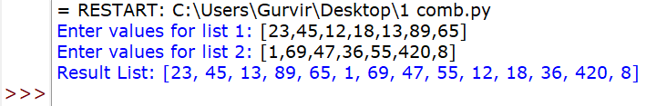

**PRACTICAL – 11**

**Aim: Program to find frequency of a word in a sentence using functions and dictionary def frequency (s).**

**File:**

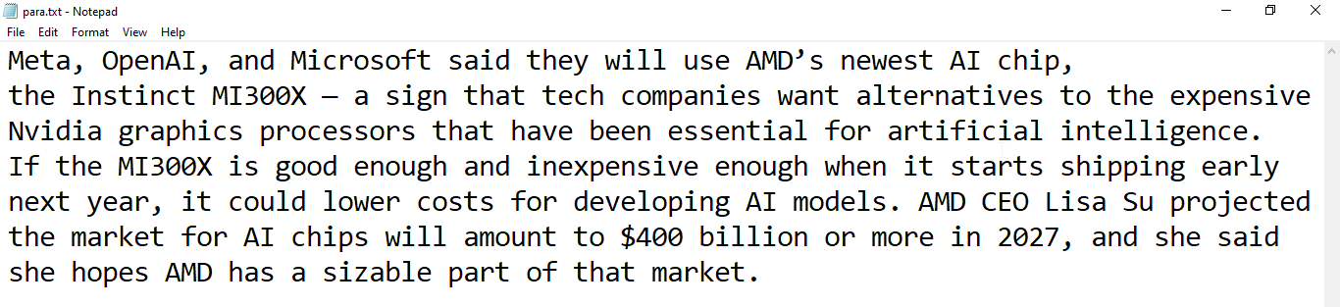

Code:

Output:

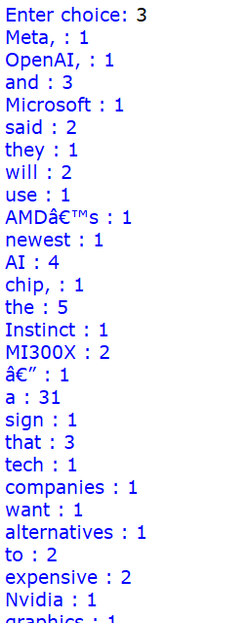

**PRACTICAL – 12**

Aim: Program to find the longest and shortest word with their length of a paragraph using functions.

**File:**



Code:

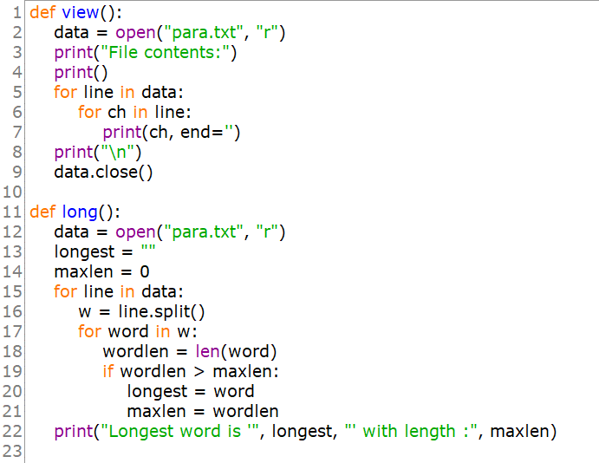

Output:

**PRACTICAL – 13**

Aim: Program to duplicate element in a list using function.

Code:

Output:

**PRACTICAL – 14**

Aim: Program to count no vowels in a para.txt.

**File:**

Code:

Output:

**PRACTICAL – 15**

Aim: Program to count no of occurrences of the word ‘the’ and ‘is’ in a para.txt.

**File:**

Code:

Output:

**PRACTICAL – 16**

Aim: Program to count the number of lines containing the word given by the user anywhere in the line in para.txt.

**File:**

Code:

Output:

**PRACTICAL – 17**

Aim: Program to store student data in a binary file taken from the user in the form of list and then display the record of those students whose age is more than 15 years.

Code:

Output:

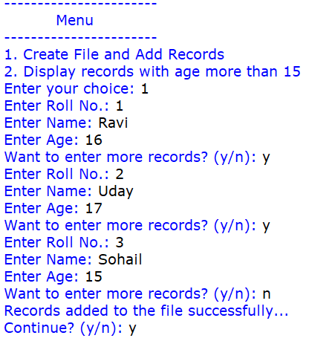

**PRACTICAL – 18**

Aim: Program to store teaches data in a binary file taken from the user in the form of dictionary and then display the record of those teachers whose experience is more than 5 and 10 years.

Code:

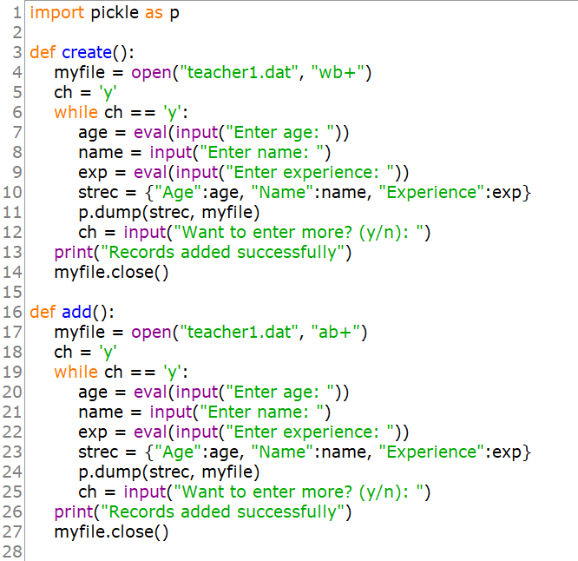

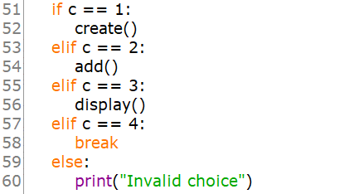

Output:

**PRACTICAL – 19**

Aim: Program to store product details in a csv file taken from user in the form of list and then display the records of those whose price is more than 100rs.

Code:

Output:

**PRACTICAL – 20**

Aim: Program to take student data from user in the form of list and show push and pop operation with that data in a stack.

Output:



